PROJECT 6
MY FIRST SEARCH AGENT
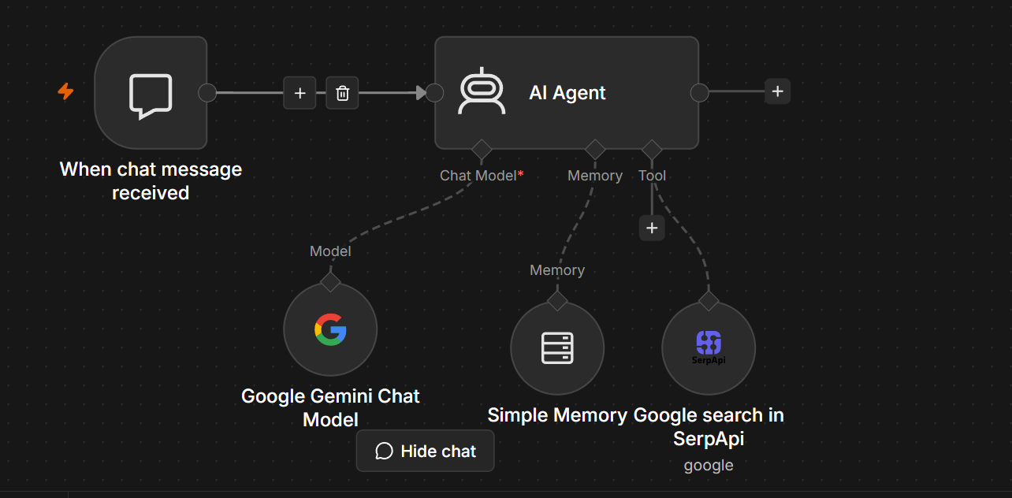
Project Information
Project Title: AI Chat Assistant with Memory and Real-Time Google Search
Platform: n8n
AI Model: Google Gemini Chat Model
Memory: Simple Memory
Search Engine: SerpAPI (Google Search)
Purpose:
Develop an intelligent conversational AI assistant capable of answering user queries using Google Gemini, retaining conversational context through memory, and retrieving up-to-date information from Google Search via SerpAPI when needed.

1. Project Overview
This workflow implements an AI-powered chatbot using n8n. The chatbot receives user messages, processes them using the Google Gemini Chat Model, remembers previous interactions through a memory component, and can access live information from Google Search using SerpAPI.
Unlike a traditional chatbot that only relies on pre-trained knowledge, this AI assistant can:
- Answer general knowledge questions.
- Remember previous parts of the conversation.
- Retrieve current information from the internet.
- Provide more accurate and context-aware responses.

2. Workflow Architecture
User Message
│
▼
When Chat Message Received
│
▼
AI Agent
├───────────────┐
│ │
▼ ▼
Google Simple Memory
Gemini
Chat Model
│
▼
Google Search
(SerpAPI)
│
▼
AI Response
│
▼
User

3. Workflow Components
Node 1: When Chat Message Received
Purpose
This node acts as the trigger for the chatbot. Whenever a user sends a message through the chat interface, the workflow is automatically initiated.
Input
Example:
What is Artificial Intelligence?
or
Who won yesterday's IPL match?
Output
The user's message is passed to the AI Agent.

Node 2: AI Agent
Purpose
The AI Agent serves as the central controller of the workflow. It coordinates the conversation by interacting with the language model, memory, and external tools to generate the best possible response.
Responsibilities
- Receives the user's message.
- Sends the message to Google Gemini.
- Retrieves previous conversation context from memory.
- Uses Google Search when current information is required.
- Combines all available information.
- Generates a final response.

Google Gemini Chat Model
Purpose
Google Gemini is the Large Language Model (LLM) responsible for understanding the user's request and generating natural-language responses.
Tasks Performed
- Understand user intent.
- Answer questions.
- Generate explanations.
- Write code.
- Summarize content.
- Assist with problem solving.
- Generate creative text.
Example
User:
Explain Machine Learning.
Gemini:
Machine Learning is a branch of Artificial Intelligence that enables computers to learn patterns from data and make predictions without being explicitly programmed.

Simple Memory
Purpose
The Simple Memory node stores previous messages exchanged during the conversation.
This enables the chatbot to maintain conversational context instead of treating each message independently.
Example
User:
My name is John.
Later...
User:
What is my name?
Without Memory:
I don't know.
With Memory:
Your name is John.
Benefits
- Maintains conversation flow.
- Supports follow-up questions.
- Improves personalization.
- Reduces repetitive input from users.

Google Search (SerpAPI)
Purpose
The SerpAPI node enables the AI Agent to retrieve current information from Google Search.
Whenever the AI determines that it requires real-time information, it sends a search request to SerpAPI.
Example Queries
Latest AI news
Weather in Hyderabad
Today's cricket score
Top AI startups in 2026
Example Search Result
Query:
Who won yesterday's IPL match?

Google Search Result:
Chennai Super Kings defeated Mumbai Indians by 5 wickets.
The AI Agent incorporates this information into its final response.

4. Complete Workflow
User sends message
│
▼
Chat Trigger
│
▼
AI Agent
│
┌──────┼────────┐
│ │ │
▼ ▼ ▼
Gemini Memory SerpAPI
│
▼
Combine Information
│
▼
Generate Response
│
▼
Return Response to User

5. Input Example
User:
Who is the CEO of Google?

6. AI Processing
The AI Agent:
- Receives the question.
- Checks conversation memory for relevant context.
- Determines if the query requires live information.
- If necessary, searches Google using SerpAPI.
- Sends the gathered context to Google Gemini.
- Receives the generated response.
- Returns the response to the user.

7. Example Responses
Example 1 – General Knowledge
User
Explain Deep Learning.
Response
Deep Learning is a subset of Machine Learning that uses artificial neural networks with multiple hidden layers to learn complex patterns from large datasets.

Example 2 – Memory
User
I live in Hyderabad.
Later...
Which city do I live in?
Response
According to our conversation, you live in Hyderabad.

Example 3 – Real-Time Search
User
What is today's gold price?
Process
AI Agent
│
▼
Google Search
│
▼
Gemini
│
▼
Response

8. Technologies Used
Technology | Purpose
n8n | Workflow Automation Platform
AI Agent Node | Workflow orchestration and tool selection
Google Gemini Chat Model | Natural Language Processing and AI responses
Simple Memory | Conversation history management
SerpAPI | Google Search integration for real-time information
Google Search | Live web search
JSON | Data exchange format

9. Workflow Advantages
- Natural and intelligent conversations.
- Maintains conversation context using memory.
- Retrieves up-to-date information from the web.
- Provides more accurate responses than static chatbots.
- Easy to integrate into websites or applications.
- Modular design that can be extended with additional tools.
- Suitable for customer support, education, research, and personal assistants.

10. Future Enhancements
- Add long-term memory using a database (e.g., PostgreSQL or Redis).
- Integrate document retrieval (RAG) for organization-specific knowledge.
- Support file uploads (PDF, Word, Excel) for question answering.
- Add voice input and text-to-speech capabilities.
- Connect to Slack, Microsoft Teams, WhatsApp, or Telegram.
- Include sentiment analysis for customer support scenarios.
- Enable multilingual conversations.
- Add user authentication and role-based access control.
- Integrate with CRM systems for personalized customer interactions.

11. Conclusion
This workflow demonstrates a modern AI-powered conversational assistant built with n8n. It combines the Google Gemini Chat Model for natural language understanding, Simple Memory for maintaining conversational context, and SerpAPI for accessing real-time information from Google Search. The AI Agent coordinates these components to provide intelligent, context-aware, and up-to-date responses, making the solution suitable for virtual assistants, customer support systems, educational platforms, and enterprise knowledge applications.

